Gaston County Art Guild
Arts on the Greenway
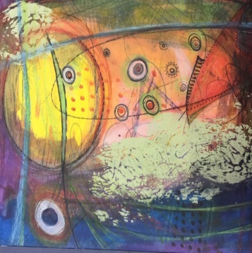
presents
FINE ARTIST
Liz McKay
JUDGE OF OUR 2018 MINIATURE SHOW
Intuitive Painting Workshop
FRIDAY, JANUARY 11, 2018, 10 AM-Noon
INCLEMENT WEATHER DATE: JAN. 18, 2018
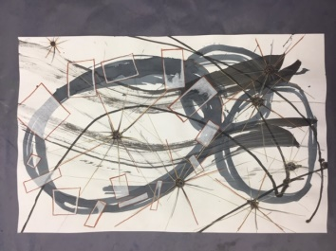
Arts on the Greenway
500 E Central Ave, Mount Holly, NC
$35 Members $40 Non- Members
All Skill Levels, Minimum Age 18, Class Size 3-10 Get to know Liz McKay
Visit GCAG website www.gastoncountyartguild.com www.meanmusestudio.com
or http://nc-kennedyart.weebly.com for registration information

INTUITIVE PTG: Liz McKay’s intuitive painting workshop is designed to release your artistic curiosity and sense of play with the ultimate objective of awakening your deep creative spirit. Working with blocks of color and line, we will begin by creating several quick, 5 minute paintings before moving on to creating one or two larger works. All of the paintings will utilize a variety of mediums on watercolor paper and can be cropped to suit for either mounting on panel or matted for framing.
SUPPLIES: Employing multiple mediums requires a lot of stuff, but don’t let that dissuade you. Below is a list of the most commonly used materials. Please don’t feel that you have to go out and buy all of this at once, just bring what you have on hand. She always brings as much extra as she has for sharing.

SUPPLY LIST:
- Cheap drawing paper or copier paper (20 sheets)
- 140 lb. Watercolor Paper (11”x14” or larger)
- Assorted acrylic paints
- Assorted paint brushes
- Charcoal & conte
- Drawing pencils
- Ball point pens
- Assorted markers (Sharpies, Microns, Pitt)
- Colored pencils
- Watercolor pencils
- Watercolor crayons
- Water soluble graphite pencils
- NuPastel or Woodless
- Color Pencils
- Spray bottle for water
- Jar for water (brush cleaning)
- Paper towels
- Matte Gel Medium
- Glue & glue sticks
- Knitting needle, box cutter blades or scraper blades
- Scissors
- Blue painters tape

FOR DOWNLOADS visit gastoncountyartguild.com or nc-kennedyart.weebly.com events page
TO JOIN Gaston County Art Guild: Go to GCAG website http://www.gastoncountyartguild.com/join.html
TO REGISTER: Email your name, phone, address, membership status, ck # & amt, workshop name to email nckennedyart@gmail.com Subject: Intuitive Painting
AND make check to GCAG and mail this completed registration, attach check to GCAG. For: Liz McKay Workshop Intuitive Ptg & mail to Attn: NC Kennedy, GCAG Workshops, PO Box 452, Gastonia, NC 28053 by January 4, 2019
PRINT LEGIBLY
Name: ______________________________ Phone# ____________________
Address: ____________________________________________________
Email:______________________________ Text: ______________________
WKSHOP Ck #_____ Amt:/ / GCAG Member: $35 / / Non-Member: $40
Join GCAG online at www.gastoncountyartguild.com/join.html (pay online or add an additional ck and membership form for chosen membership level) / /Joining online / / Joining GCAG Ck#_____ Amount $______

20181130

