Gaston County Art Guild
Arts on the Greenway

AWARD WINNING BOOK & PAPER ARTIST
Lore Spivey
PRESENTED MOVEABLE BOOKS: HISTORY, HIJINKS, HOW-TO AT OUR RECENT MEETING AND
NOW PRESENTS TWO WORKSHOPS
Dating back as early as the 13th century, moveable books were originally created as educational resources for adults. Commonly called Pop-Ups today, these mesmerizing frameworks can be used alone as sculpture or cards, or grouped together in book form to tell a longer story. In this workshop Lore Spivey will teach techniques for different cards. Come ready to play as we gain skills to create Cards with Personality, Originality, Playfulness!
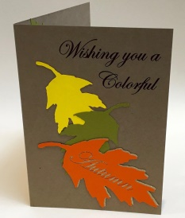
Fall Themed Pop-Up Cards Workshop
WEDNESDAY
OCTOBER 24, 2018
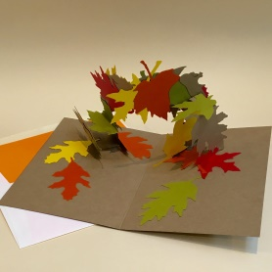
OR NOVEMBER 14, 2018
11:30 AM – 1 PM
Arts on the Greenway
500 E Central Ave,
Mount Holly, NC
$40 Members $45 Non-Members
For All Skill Levels, Supplies Included
Minimum Age 12
Visit http://nc-kennedyart.weebly.com or GCAG website www.gastoncountyartguild.com for registration information

We will use the vivid colors of autumn as inspiration to create three-dimensional pop-up cards. These cards make lovely gifts, or memorable keepsakes. All supplies are included. Questions? email nckennedyart@gmail.com Subject Line: Pop-UpCards Workshop

Lore Spivey is a self-taught, award winning, book and paper artist. She is a member of the Moveable Book Society. She holds degrees in theatre education from both Universities of North Carolina at Asheville (BA) and Greensboro (MEd.). Lore taught high school theatre arts for 17 years. She employs scenic design elements extensively in her three-dimensional books. Lore has studied with Carol Barton of Popular Kinetics Press. Before settling back home in Gastonia, Lore lived in Alabama, California, and Osaka, Japan. The ornate gardens of Japan have influenced her work, and nature continues to be one of her major themes.

POST THIS OR CARRY WITH YOU TO SHARE WITH FRIENDS
REGISTER NOW FOR…
…………………………………………
Lore Spivey Pop-Up Card Wkshop
http://nc-kennedyart.weebly.com
www.gastoncountyartguild.com
…………………………………………
Lore Spivey Pop-Up Card Wkshop
http://nc-kennedyart.weebly.com
www.gastoncountyartguild.com
…………………………………………
Lore Spivey Pop-Up Card Wkshop
http://nc-kennedyart.weebly.com
www.gastoncountyartguild.com
…………………………………………
Lore Spivey Pop-Up Card Wkshop
http://nc-kennedyart.weebly.com
www.gastoncountyartguild.com
…………………………………………
Lore Spivey Pop-Up Card Wkshop
http://nc-kennedyart.weebly.com
www.gastoncountyartguild.com
…………………………………………
Lore Spivey Pop-Up Card Wkshop
http://nc-kennedyart.weebly.com
www.gastoncountyartguild.com
…………………………………………
Lore Spivey Pop-Up Card Wkshop
http://nc-kennedyart.weebly.com
www.gastoncountyartguild.com
…………………………………………
Lore Spivey Pop-Up Card Wkshop
http://nc-kennedyart.weebly.com
www.gastoncountyartguild.com
…………………………………………
Lore Spivey Pop-Up Card Wkshop
http://nc-kennedyart.weebly.com
www.gastoncountyartguild.com
…………………………………………
Lore Spivey Pop-Up Card Wkshop
http://nc-kennedyart.weebly.com
www.gastoncountyartguild.com
…………………………………………
Lore Spivey Pop-Up Card Wkshop
http://nc-kennedyart.weebly.com
www.gastoncountyartguild.com
…………………………………………
Lore Spivey Pop-Up Card Wkshop
http://nc-kennedyart.weebly.com
www.gastoncountyartguild.com
…………………………………………
Lore Spivey Pop-Up Card Wkshop
http://nc-kennedyart.weebly.com
www.gastoncountyartguild.com
…………………………………………

