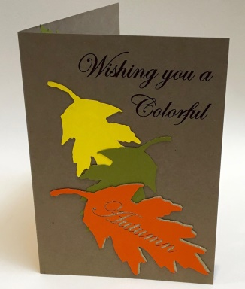
AWARD WINNING BOOK & PAPER ARTIST
Lore Spivey
Fall Themed Pop-Up Cards Workshop
WEDNESDAY
OCTOBER 24 OR NOVEMBER 14, 2018
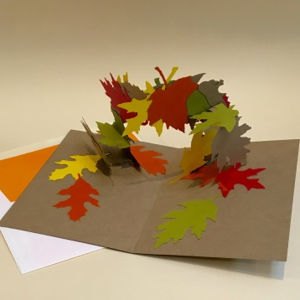
11:30 AM – 1 PM
Arts on the Greenway
500 E Central Ave, Mount Holly, NC
$40 GCAG Members $45 Non-Members
For All Skill Levels, Supplies Included. Minimum Age 12
Visit http://nc-kennedyart.weebly.com or GCAG website www.gastoncountyartguild.com for registration information

We will use the vivid colors of autumn as inspiration to create three-dimensional pop-up cards. These cards make lovely gifts, or memorable keepsakes. All supplies are included. Min. class size: 4, max. class size: 16 Questions? email nckennedyart@gmail.com Subject Line: Pop-UpCards Workshop

Lore Spivey is a self-taught, award winning, book and paper artist. She is a member of the Moveable Book Society. She holds degrees in theatre education from both Universities of North Carolina at Asheville (BA) and Greensboro (MEd.). Lore taught high school theatre arts for 17 years. She employs scenic design elements extensively in her three-dimensional books. Lore has studied with Carol Barton of Popular Kinetics Press. Before settling back home in Gastonia, Lore lived in Alabama, California, and Osaka, Japan. The ornate gardens of Japan have influenced her work, and nature continues to be one of her major themes.

TO REGISTER: Go to GCAG www.gastoncountyartguild.com Click on Classes. Register online.
Or Email nckennedyart@gmail.com or
PRINT LEGIBLY
Name: ______________________________ Phone# ____________________
Address: _______________________________________________________
Email:______________________________ Text: ______________________
CHOOSE: / / WEDNESDAY OCTOBER 24
OR / / WEDNESDAY, NOVEMBER 14
/ / Gaston County Art Guild Member: $40 / / Non-Member: $45 Join GCAG or Register online at www.gastoncountyartguild.com
Or contact Nancy Kennedy nckennedyart@gmail.com Subject Line; Fall Themed Pop Up Card Workshop

