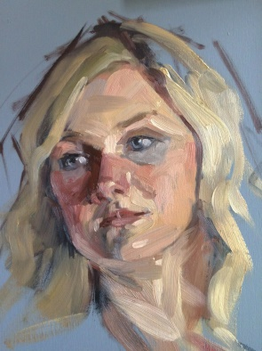
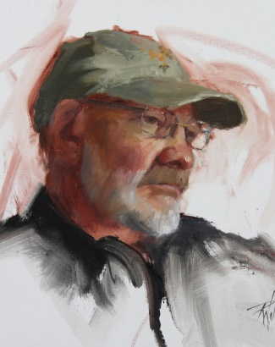
Gaston County Art Guild
Arts on the Greenway
presents
AWARD WINNING FINE ARTIST
Robin Wellner
PRESENTER AT GCAG FEBRUARY MEETING
Alla Prima Portraits
Using the Zorn Palette
THUR. MAY 2, 6 PM AotG for Robin’s Artist Talk
WORKSHOP: FRI.-SUN., MAY 3-5, 2019 9:30 AM- 4:30 PM
Arts on the Greenway
500 E. Central Ave, Mt. Holly, NC
Park and enter side door on Alexander St, Doors open 9 am-5 pm,
$325 GCAG Members $355 Non-Members
+$50 Model Fee all students
Intermediate to Advanced Artists. Can be new to Portraits.
For registration information and downloads visit http://nc-kennedyart.weebly.com or GCAG website www.gastoncountyartguild.com . Visit Robin Wellner online www.robinwellner.com

FORMAT: Robin Wellner will demo each morning teaching us about Anders Zorn and his limited palette. You actually begin at home prior to your arrival with homework so you’ll have valuable experience for a great beginning. Her Artist Talk Thursday night is open to the public. Friday she will teach the Alla Prima method of wet on wet painting with daily morning demos followed by lunch. Bring your own lunch or we will place morning orders for lunch in studio. Each afternoon you’ll paint from a model while Robin frequents your easel with lots of one-on-one time where she will teach to your needs with gentle instruction and discussion.
Simplifying your color palette to just three colors and white will give you freedom to focus on other details in portraiture. Zorn's limited palette offers a beautiful range of skin tones and you're virtually guaranteed color harmony in your painting. From life, Robin will focus on measuring to get a likeness, facial features, painting the model values, painting shapes instead of lines and of course - color!!!
There is nothing like painting from life! Even if you choose to paint from photos in the future, painting from life will give you valuable information that will help you in your work. The supply list will be emailed or will be a download.
DOWNLOADS: visit nc-kennedyart.weebly.com events page, scroll left column to Robin Wellner Workshop. downloads. JOIN, REGISTRATION, POSTER, ABOUT, SUPPLY LIST, HOMEWORK
TO JOIN: Gaston County Art Guild: GO TO nc-kennedyart.weebly.com, scroll to Robin Wellner workshop, download membership form, fill it out, attach membership check and mail with this registration form.

TO REGISTER: 1) Fill out this registration form.
2) Fill out your check TO “GCAG” AMT: “$375” GCAG members OR ”$405” non-members (see last line below) and at bottom left of check FOR “R Wellner Workshop” 3) I’ll save your seat until postmarked payment arrives if you email your name, phone, ck # & amt,to nckennedyart@gmail.com Subject: R Wellner Workshop
4) Attach check to this registration and mail Attn: NC Kennedy, % GCAG Workshops, PO Box 452, Gastonia, NC 28053 by April 27, 2019

PRINT LEGIBLY
Name: ______________________________ Phone# ________________ QUESTIONS
Address: ___________________________________________________ EMAIL Email:______________________________ Text: _______________ nckennedyart@gmail.com
Your Web:______________________ Facebook _____________Other_____________________
WKSHOP Ck #_____ Amt: / / GCAG Member: $325+$50=$375 / / Non-Member: $355+ $50= $405
2019021610P

