Gaston County Art Guild
& Arts on the Greenway
Present a Workshop by
AWARD WINNING ARTIST
& FEB. 12 GCAG MEETING DEMO PRESENTER
Robin Wellner
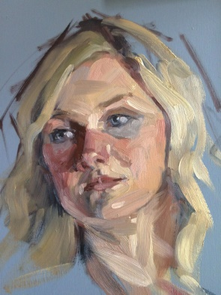
Alla Prima
Portraits
Using the Zorn Palette
FRI.-SUN., MAY 3-5, 2019
9:30 AM – 4:30 PM
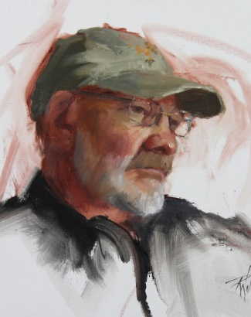
Arts on the Greenway
500 E Central Ave, Mt. Holly, NC
$325 Members $355 Non-Members
+$50 Model Fee each student
For Intermediate & Advanced Artists
Visit http://nc-kennedyart.weebly.com or
GCAG website www.gastoncountyartguild.com
for registration information and downloads

Portraits are challenging --- but so rewarding! Simplifying your color palette to just three colors and white will give you freedom to focus on other details in portraiture. Anders Zorn's limited palette offers a beautiful range of skin tones and you're virtually guaranteed color harmony in your painting. From life, we will focus on measuring to get a likeness, facial features, painting the model values, painting shapes instead of lines and of course - color!!!
We will start each morning with instruction and a demo, painting the model "alla prima" (wet-on-wet) from life. After lunch you will all have the opportunity to paint the model with lots of one-on-one instruction and gentle critiquing. There is nothing like painting from life! Even if you choose to paint from photos in the future, painting from life will give you valuable information that will help you in your work.

ABOUT THE ARTIST: Robin Wellner www.robinwellner.com
Robin is an avid painter of people as well as landscapes and plein air. Her fascination with painting faces has led her to many impressive national awards and inclusion in national shows with the American Women Artists, Oil Painters of America and beyond in Richeson 75 Figure and Portrait International Show. She maintains a practice of painting from life on a weekly basis in Charlotte, NC where she and her husband reside. Her training evolved from Fine Arts in college to workshops with renowned artists such as Dawn Whitelaw, Robert Liberace, Rich Nelson, Chris Saper and numerous others. Her focus includes figurative and portrait painting as well as plein air landscapes. To see her works and awards visit robinwellner.com
POST THIS OR CARRY WITH YOU TO SHARE WITH FRIENDS
FOR INFO, DOWNLOADS & TO REGISTER http://nc-kennedyart.weebly.com
or nc-kennedyart@gmail.com
…………………………………………
Robin Wellner ZornPalette Wkshop
http://nc-kennedyart.weebly.com
www.gastoncountyartguild.com
…………………………………………
Robin Wellner ZornPalette Wkshop
http://nc-kennedyart.weebly.com
www.gastoncountyartguild.com
…………………………………………
Robin Wellner ZornPalette Wkshop
http://nc-kennedyart.weebly.com
www.gastoncountyartguild.com
…………………………………………
Robin Wellner ZornPalette Wkshop
http://nc-kennedyart.weebly.com
www.gastoncountyartguild.com
…………………………………………
Robin Wellner ZornPalette Wkshop
http://nc-kennedyart.weebly.com
www.gastoncountyartguild.com
…………………………………………
Robin Wellner ZornPalette Wkshop
http://nc-kennedyart.weebly.com
www.gastoncountyartguild.com
…………………………………………
Robin Wellner ZornPalette Wkshop
http://nc-kennedyart.weebly.com
www.gastoncountyartguild.com
…………………………………………
Robin Wellner ZornPalette Wkshop
http://nc-kennedyart.weebly.com
www.gastoncountyartguild.com
…………………………………………
Robin Wellner ZornPalette Wkshop
http://nc-kennedyart.weebly.com
www.gastoncountyartguild.com
…………………………………………
Robin Wellner ZornPalette Wkshop
http://nc-kennedyart.weebly.com
www.gastoncountyartguild.com
…………………………………………
Robin Wellner ZornPalette Wkshop
http://nc-kennedyart.weebly.com
www.gastoncountyartguild.com
…………………………………………
Robin Wellner ZornPalette Wkshop
http://nc-kennedyart.weebly.com
www.gastoncountyartguild.com
…………………………………………
Robin Wellner ZornPalette Wkshop
http://nc-kennedyart.weebly.com
www.gastoncountyartguild.com

L

